Florida Polygraph Association
Quarterly Newsletter
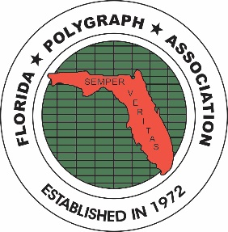
March 2024

MESSAGE FROM THE BOARD
We hope this newsletter finds you all well. We want to share some important messages from our Board Members:
From Richard Tullis:
Join us in making a difference with the Len Umanoff Memorial Scholarship Raffle! Our annual scholarship fund raffle will be during our next FPA Seminar in November, and we need your help. Do you have items to spare? Whether it's artwork, crafts, gift baskets, collectibles or gift cards, your donation to the scholarship fund raffle can change a student’s life! Reach out to Board Member Richard Tullis if you have any questions about contributing items for this year’s raffle. Let's make an impact together. Your generosity can brighten someone's future!

Also, please note the DEADLINE for scholarship submission of the Len Umanoff Memorial Scholarship is MAY 05, 2024. The application must be completed and received by MAY 05, 2024. Applications cannot be Faxed or E-mailed. These will be awarded at the November 2024 FPA Seminar. The application document and further information can be found at https://www.floridapolygraph.org/umanoff.

From Joe Waters:
Joe was kind enough to contact DCF regarding a question posed by members as to whether polygraph examiners are part of the professional class of mandatory reporters. This is what he learned from DCF:
Florida law specifies that everyone, including polygraph examiners, MUST report child and elder abuse. However, since examiners are NOT in the professional class of mandatory reporters, they do not have to provide their names. They can report such abuse by telephone to the hotline number, by mail using the online report, or through the online abuse website. Remember, failure to report or making false reports are classified as felonies.

From Sandy Dunn:
The Board of Directors would like to thank Chris Conley for his service on the board. Unfortunately, Chris made the tough decision to step down from the board due to his increasingly busy schedule. Chris was a great asset to the board and was instrumental with setting up a system to send out surveys so we can get much needed feedback from our members.

Wishing Everyone a Happy Spring!

IN THE NEWS
POLYGRAPH NEWS
- A new article authored by Raymond Nelson discussed multiplicity effects in using serial single-issue (SSI) screening testing as it has been suggested with the SIST. The SIST was first suggested in 2022. The suggestion was to use the DLST format (renamed as SIST) with one relevant screening issue being asked twice during one test (2RQs, same issue). This would require most agencies/examiners to run four single issue screening tests on each applicant. The results of Nelson’s research “Failed to support the SSI hypothesis as advantageous when compared to the results of traditional multi-issue screening [tests]”. The evidence thus far does not support it. See Nelson, R. (2024) Short Report: Bootstrap Analysis of Serial Testing Effects Using Laboratory Data. Polygraph & Forensic Credibility Assessment: A Journal of Science and Field Practice 53(1):63-68
- In an article from the APA Magazine, the authors suggested utilizing the Utah CQT 4RQs for single issue screening testing as an alternative to the BOST. This was presented as an option at the November 2023 seminar. See Blalock et al., (2023) An Effective Strategy for Improving Single-Issue Screening Exams. APA Magazine 56(5): 136-139

Congratulations to Joe Pirro for being awarded a FPA Lifetime Membership. We are thankful for his service as FPA President!

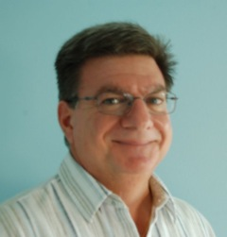

CURRENT FPA BOARD MEMBERS
President | Sandy Dunn
Vice President - Private | Jim Orr
Vice President – Public | Open
Treasurer | John Thorpe
Secretary | Ben Blalock
Board Member | Mary Brown
Board Member | Joe Waters
Borad Member | Max Nunziata
Board Member | Richard Tullis
Ex Officio Members
Assistant Treasurer | Trish Orr
School Director | Contact Sandy Dunn
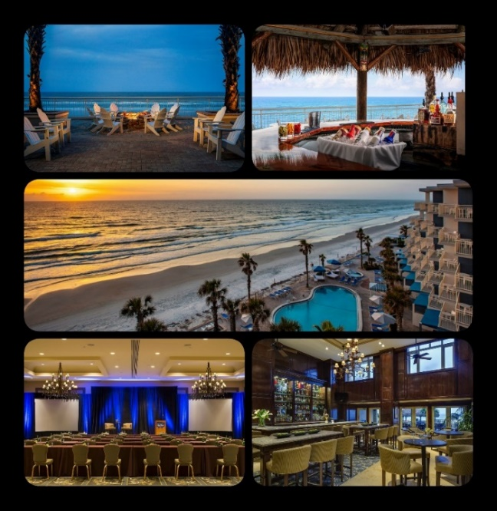
SAVE THE DATE
2024 FPA Seminar will be at Daytona Beach Shores Resort & Spa from 11/20 - 24, 2024
Schedule will be announced in April
SURVEY RESULTS

A survey was sent to all members regarding the 2025 Seminar. Thank you to all the members who participated in the survey! Below are the results of the survey:
