POLYGRAPH CHAIR GIVEAWAY
Hi John and FPA Members;

Hope all is well. I have a Limestone Polygraph chair in great condition, free to anyone that will come and get it in my Tampa office.

Wade Moss, agipvt@gate.net

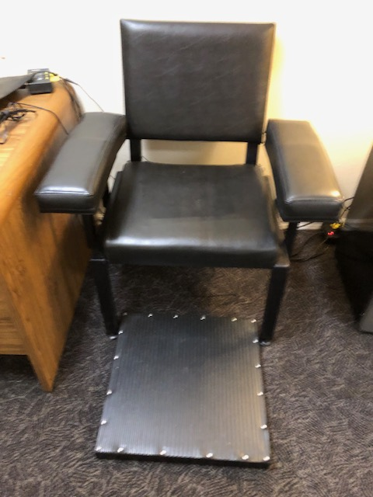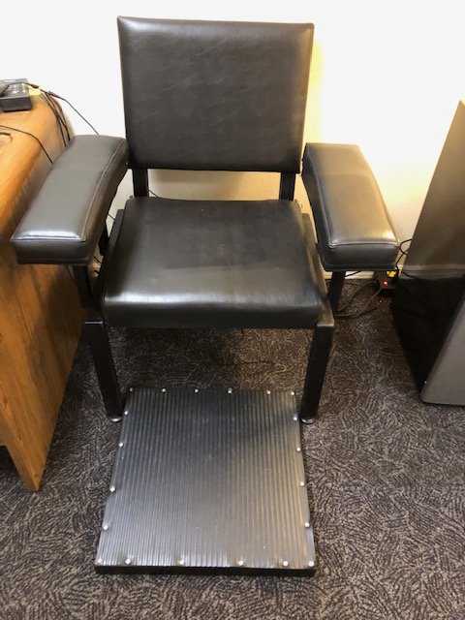

You can contact Wade at: ﻿Tampa Office Address
> 5474 Williams Rd
> Suite 2C
> Tampa, FL 33610

They can also telephone Wade at: (727) 243-3760

Cc: newsletter,archives 02/26/2024 /wm,jt

