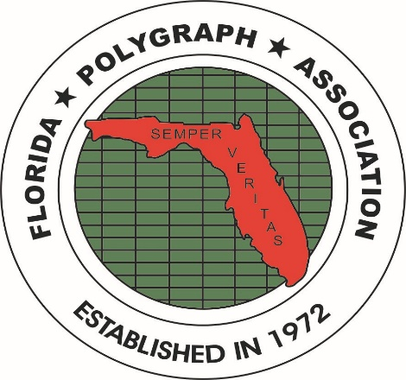
FLORIDA POLYGRAPH ASSOCIATION
WWW.FLORIDAPOLYGRAPH.ORG

LEN UMANOFF SCHOLARSHIP AWARD ANNOUNCEMENT

The FPA Board of Directors announces yet another yearly scholarship award. The FPA
Scholarship was named for Len Umanoff, a military veteran, long time FPA member and
long time officer in the FPA.

Each year, the FPA offers a scholarship to children and grand children of FPA members. The
scholarship application is loaded in the FPA Web Site. It can be downloaded.

The scholarship application, along with supporting required documents must be mailed
to a FPA Board Member, or the Scholarship Chair Person, Richard Tullis. The FPA does not accept faxed or E-mail copies of the application. It must also be postmarked by MAY 5 of 2024.

The Len Umanoff Scholarship Award is totally funded by the generosity of its members via
donations and the raffling off of items donated by members at each seminar. No operating funds are utilized to fund this scholarship.

Remember that there are certain requirements for the application process, so please go online to the FPA Web Site and download the application.

If you have eligible children or grandchildren, please get the application in prior to the deadline of May 05, 2024. The award(s) will be announced at the November 2024 Seminar.

